Chapter 4, Problem 77.

Solve Prob. 4.44 using PSpice.

Chapter 4, Problem 44.

For the circuit in Fig. 4.111, obtain the Thevenin equivalent as seen from terminals
- a-b and (b) b-c.

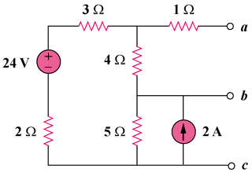

Figure 4.111
For Prob. 4.77.

